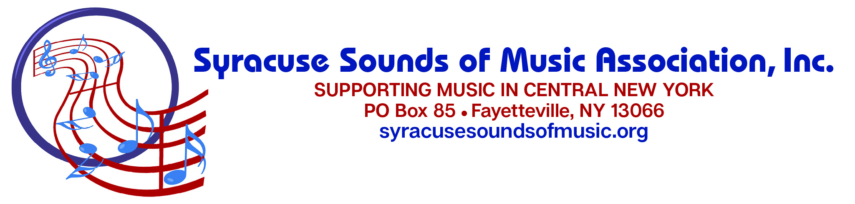
GRANTS IN MUSIC APPLICATION
Your application must be received by mail and must be postmarked by 01/15/2021.
No email submissions will be accepted.

Name of organization seeking funding:

Secure mailing address for all grant correspondence and awards:

Contact person & title for general grant correspondence:

Name: Phone: Email:

Financial contact person for financial info and awards, if different:

Name: Phone: Email:

Amount requested:
$

Organization mission statement:

GRANT CATEGORIES: We do not provide funding for operating expenses or scholarships. The SSMA provides grant assistance in the categories listed below. Please check any category that matches the objectives of the proposed project:

___Financial support for a concert or performance

___Hiring guest artists
___Purchase of music
___Other (please specify within the application

___Continuing education projects

___Student tuition

___Purchase of instruments or other music equipment

___Repair of instrument(s)

Organization name: ____________________________________________________________________________________

Project description and plans for implementation:

Rationale for project:

Collaboration with other groups:

Overall budget for the project:

Please also enclose a summary of your organization’s annual budget.

Organization name: ___________________________________________________________________________________

Persons/groups to be served, including estimated number of persons to be served:

Anticipated time for project completion:

Please enclose proof of 501(c)(3) non-profit organization status from the IRS.

Applicant’s signature Date

Return application to:
Grants in Music
P.O. Box 85
Fayetteville, NY 13066

Applicants will be notified in February 2021.

2021 Grant Application Checklist

Please be sure you have included the following with your application:

- Report, if you received a grant from Syracuse Sounds of Music Association last year and have not already sent it to us. A letter was sent with your award in December listing the required information, and a report form was also sent to you via email. The report form is on the SSMA website if you want to download it. You are not required to use the form, but the report is required with the information specified.

- Verification of 501(c)(3) non-profit organization status from the IRS.
- Secure mailing address for all mail correspondence and receipts.
- Project Budget
- Summary of your organization’s Overall Annual Budget

Additional tips:

Be brief and concise on the application. You may enclose supporting materials.

Write as though you are a new applicant, even if you have applied in the past.
We have new board and grant committee members each year who may not be
familiar with your organization.

We will be accepting applications between November 1, 2020 and January 15, 2021.

Please carefully review your application and be sure that any supporting material you send has each page labeled with your organization’s name.

Your grant application must be postmarked by January 15, 2021 to be considered.

